CSIT115 L5

Basic Concepts

Data model ? What is it ?

A data model provides an abstract view of data that can be used for datadefinition, data manipulation, data retrieval, and data administration

Because a data model provides an abstract view it is also commonly called as a view of data

In the past we talked about the following views of data:

* Sector, track, cylinder
* Sequence of data blocks
* Record, file, file system
* Two dimensional tables (tabular view), Hierarchies (tree view), Networks (graph view)
* Classes of objects, associations, attributes

What view of data provides Relational Model of Data ?

The model provide a tabular view of data

* A relational table consists of a header and theoretically an unlimited number of rows
* A header consists of a sequence of attribute names
* A row consists of a sequence of values of attributes
* A vertical sequence of attribute name followed by the attribute values is called a column
* A header is also called a relational schema
* A set of all values of an attribute is called a domain of an attribute
* A database is a set of relational tables

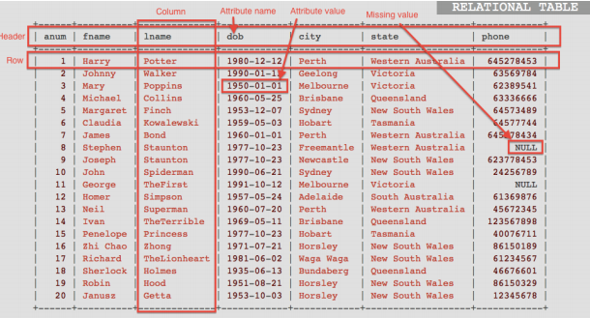

Keys

Examples:

* A set of attributes {snum} is a minimal key in a relational schema STUDENT={snum, first-name, last-name, date-of-birth}
* A set of attributes {snum, last-name} is a superkey in a relational schema STUDENT={snum, first-name, last-name, date-of-birth}

All minimal keys valid in a relational schema are also called as candidate keys

A primary key is one of the candidate keys arbitrarily chosen by a database designer to uniquely identify the rows in a relational table

NULL

A NULL constraint says that an attribute in a relational table may have no values at all

With an exception saying that no column belonging to a primary key or candidate key is allowed to take on NULL for any row (it is also called as Entity Integrity constraint)

Domain Constraints

A domain constraint is a condition imposed on the values of an attribute

A that determines the values of dom(A), i.e. a domain of attribute A.

Examples:

* An attribute student-number is a sequence of 7 digits
* An attribute date-of-birth cannot have a value greater then todays date
* An attribute salary is a positive real number
* A value of an attribute gender can be either 'female' or 'male'
* A value of an attribute credits can be either 6 or 12
* A value of an attribute first-name is a string of letters an blanks that starts from a capital letter

Summary

A database is a collection of relational tables

A relational table consists of rows (tuples) and columns (attributes)

All attributes have atomic values

Each attribute has a domain, it means, that a set of acceptable values

A row represents a relationship among a set of attributes

A relational table is a subset of the Cartesian Product of attribute domains

An attribute may have no value (NULL)

A relational table implements either a class of objects or an association

All identifiers in a conceptual schema are implemented as the keys in the relational tables

A "tourist guide" through a "land of keys"

* Minimal key => the smallest key
* Superkey => minimal key + other attribute(s)
* Candidate key => any minimal key
* Primary key => one of candidate keys
* Foreign key => an attribute or set of attributes referencing a primary key or a candidate key in another or the same relational table